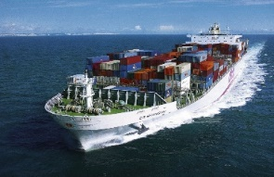
TAO BALINGA
Shipping, Cleaning & Forwarding Agent
43, Container Complex TCIP, Tin Can Island, Apapa-Lagos
Tel: 08033022869, 08024070611
INTEGRATED SERVICES NIGERIA LIMITED

TAO BALINGA
INVOICE NO:

OFFICIAL RECEIPT
№ 0008613
DATE:
Received From
Naira
The Sum of
Being full/part payment for
CASH/CHEQUE NO

FOR: TAO BALINGA INTEGRATED SERVICES (NIG.) LTD
BALANCE
ADVANCE
N

